**ETHNUS WEBINAR – AWS PROJECT DOCUMENT**

**NAME: SANGA PRIYA.JB**

**SCREENSHOTS**

**DASHBOARDS:**

1. AWS login screen

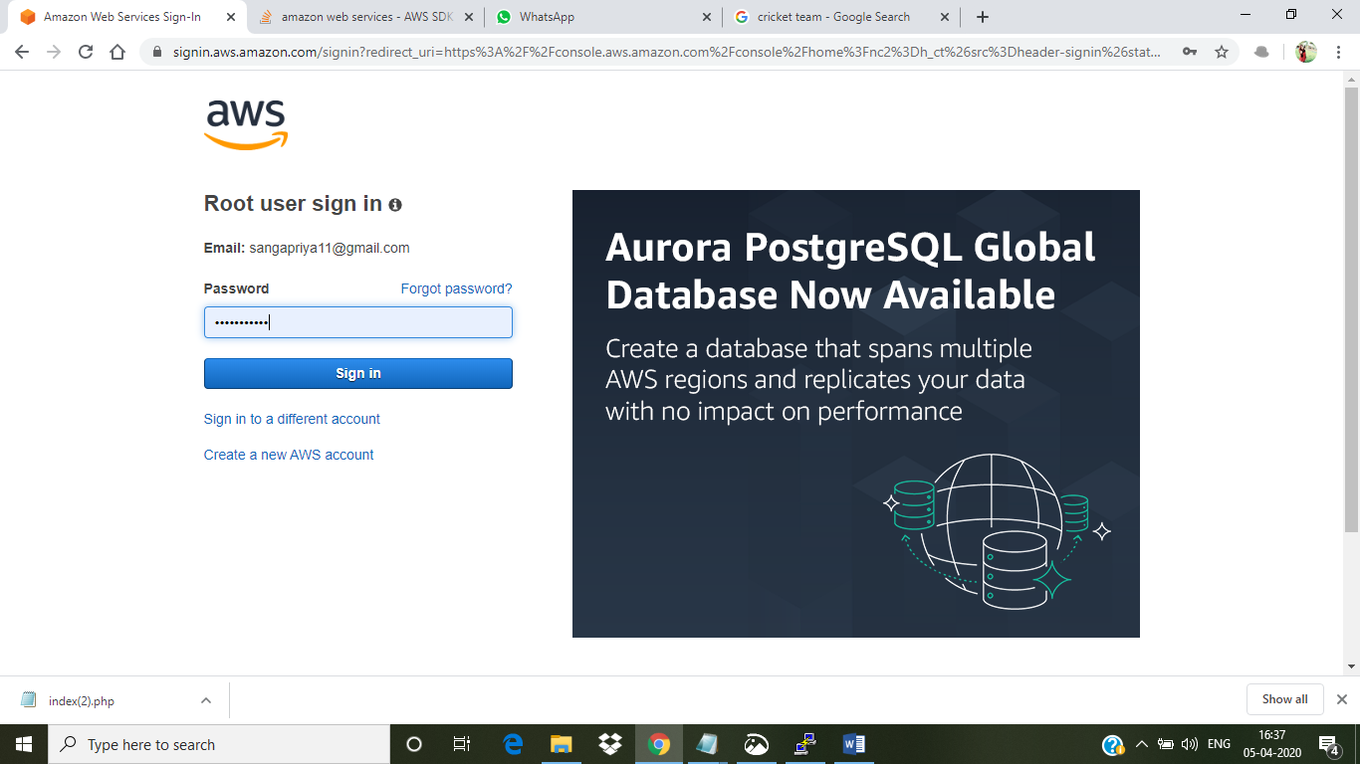

1. EC2 Dashboard

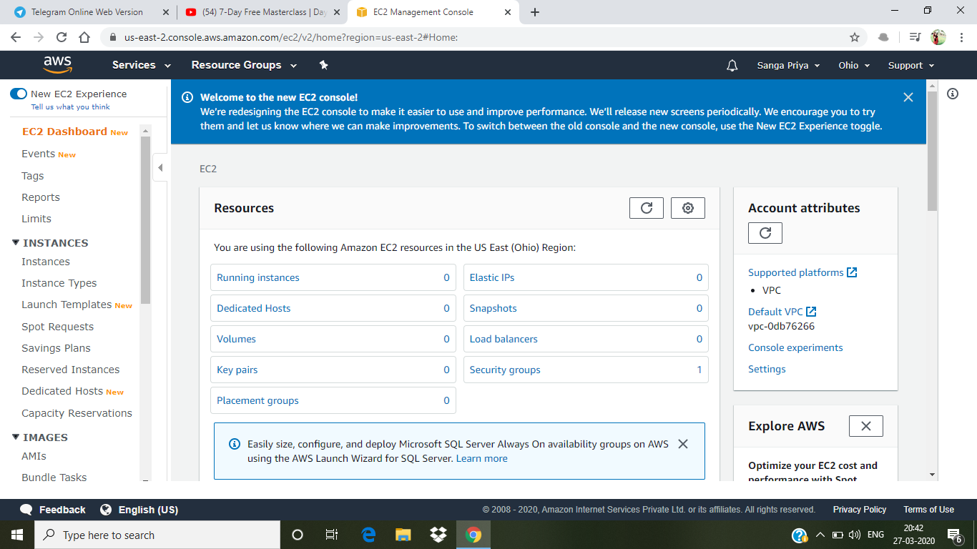

1. S3 Dashboard

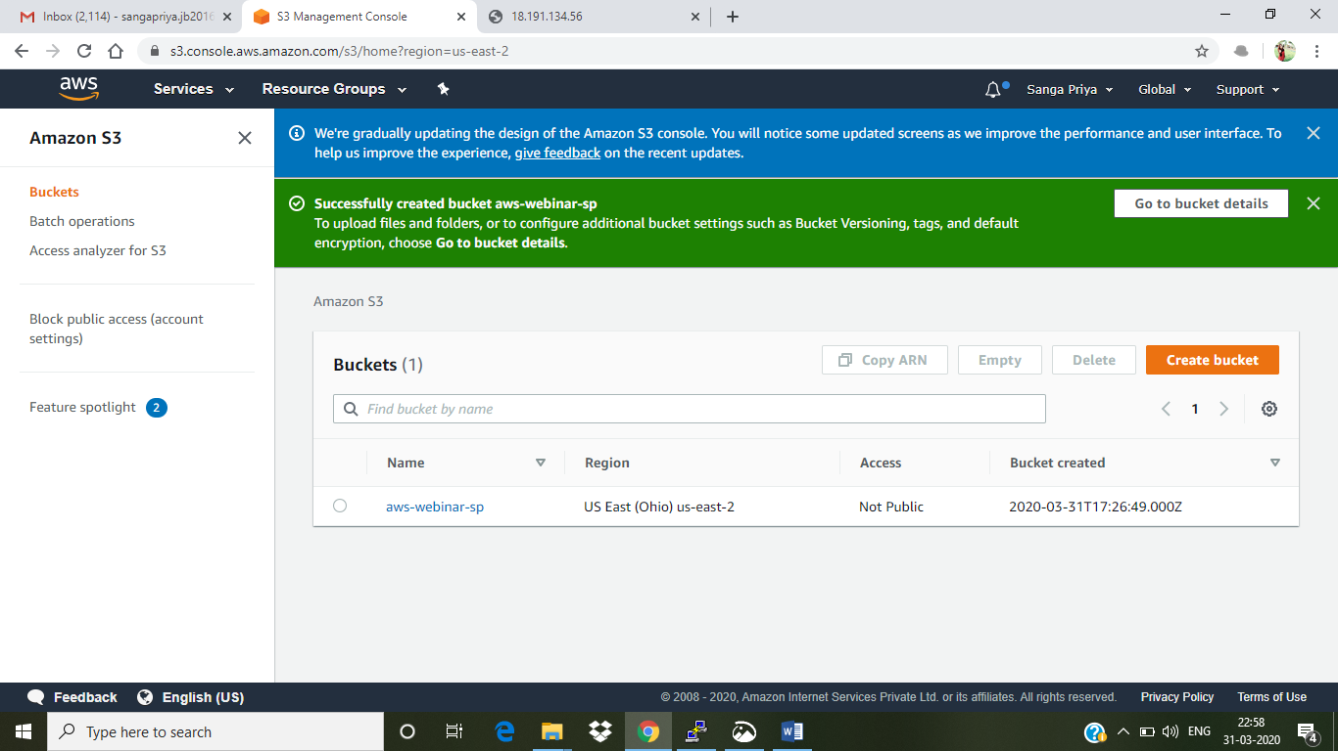

1. Rekognition Dashboard

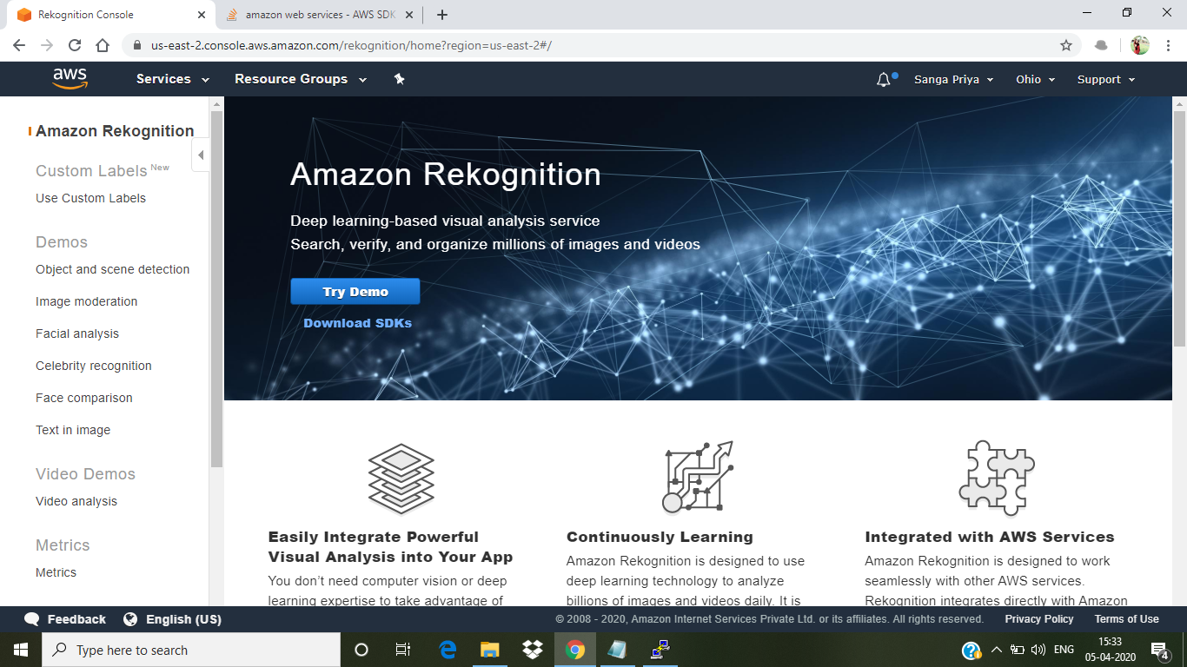

**EC2:**

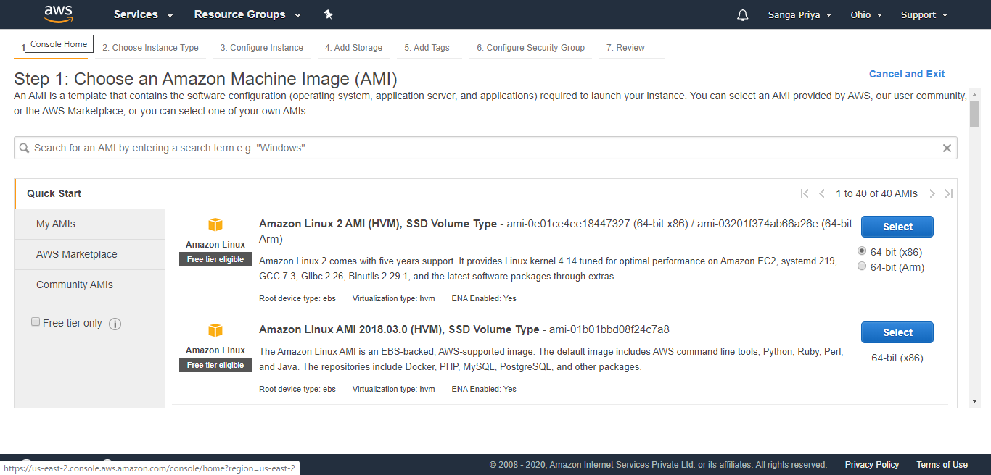

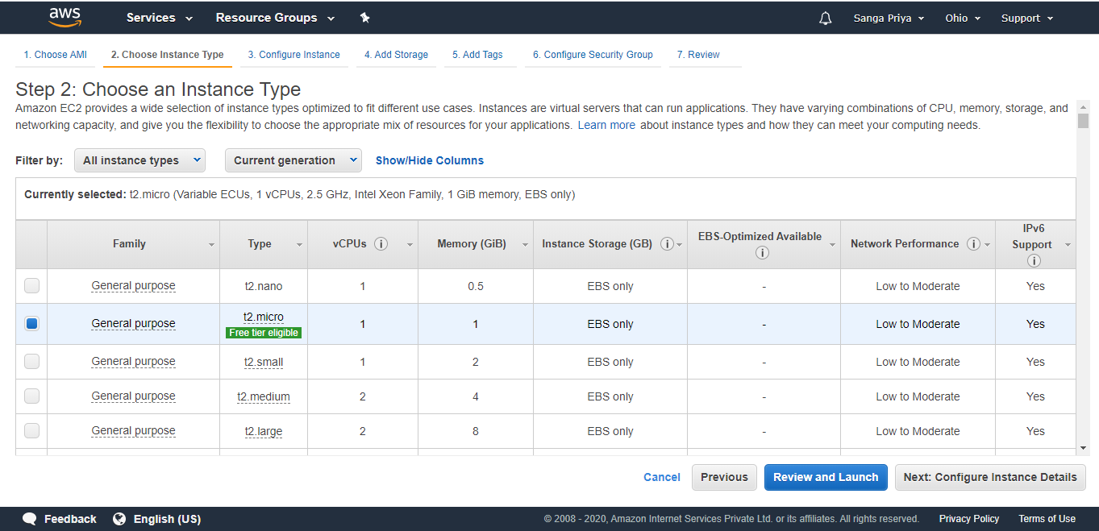

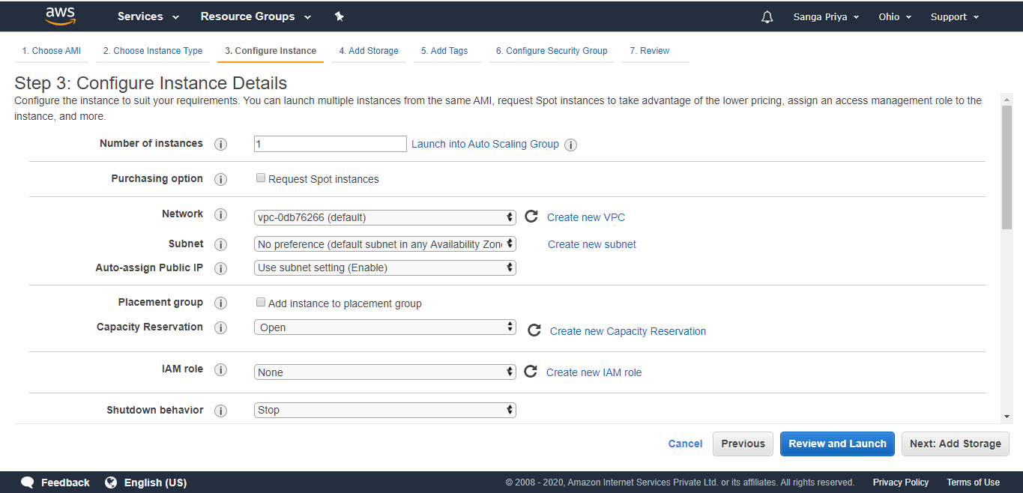

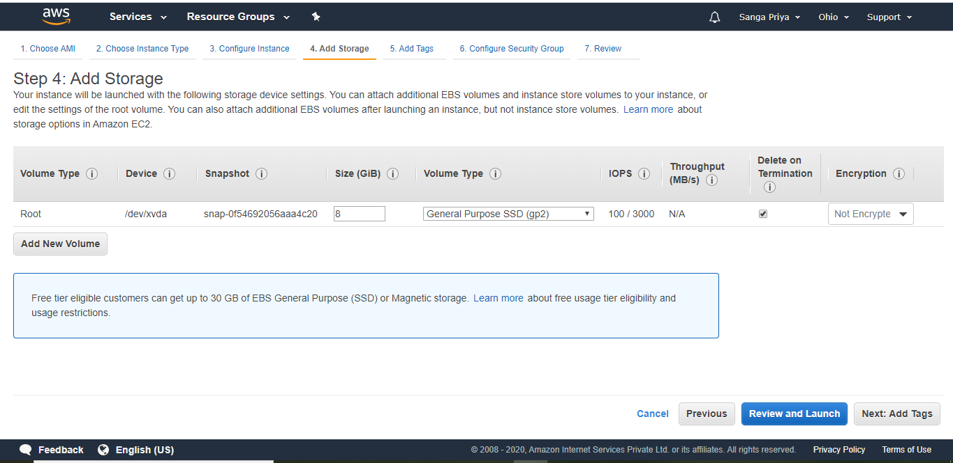

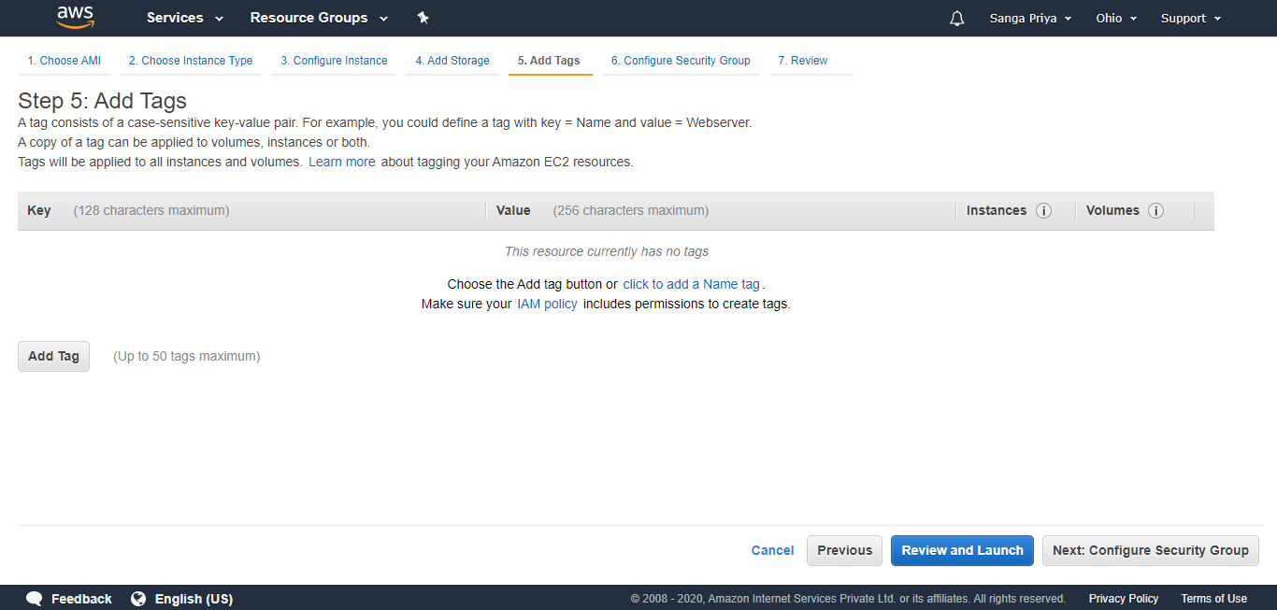

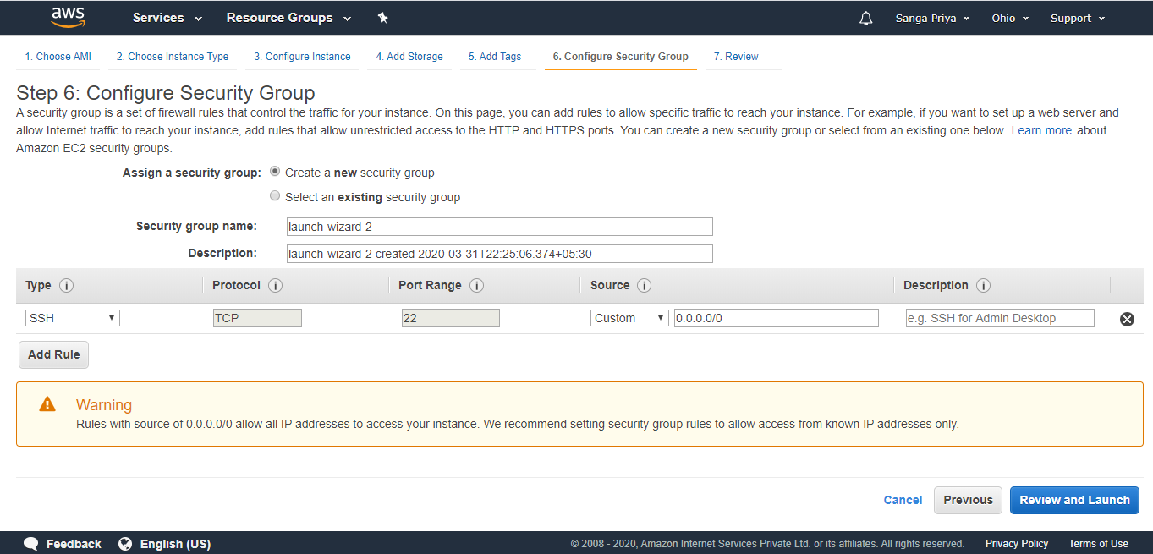

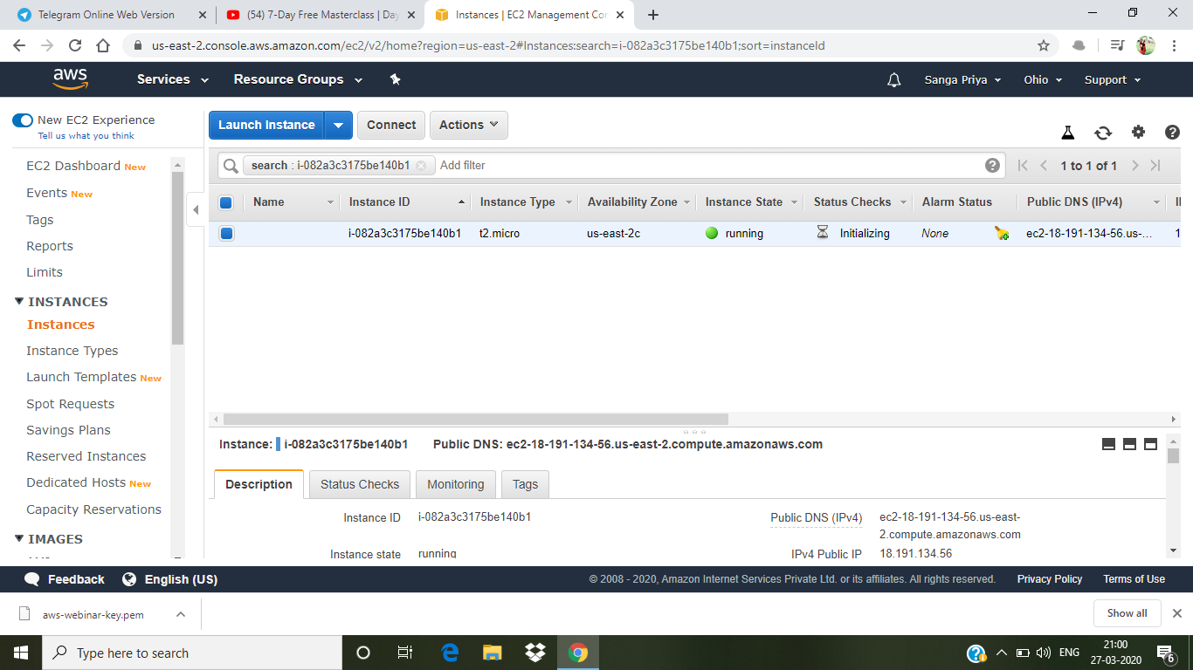

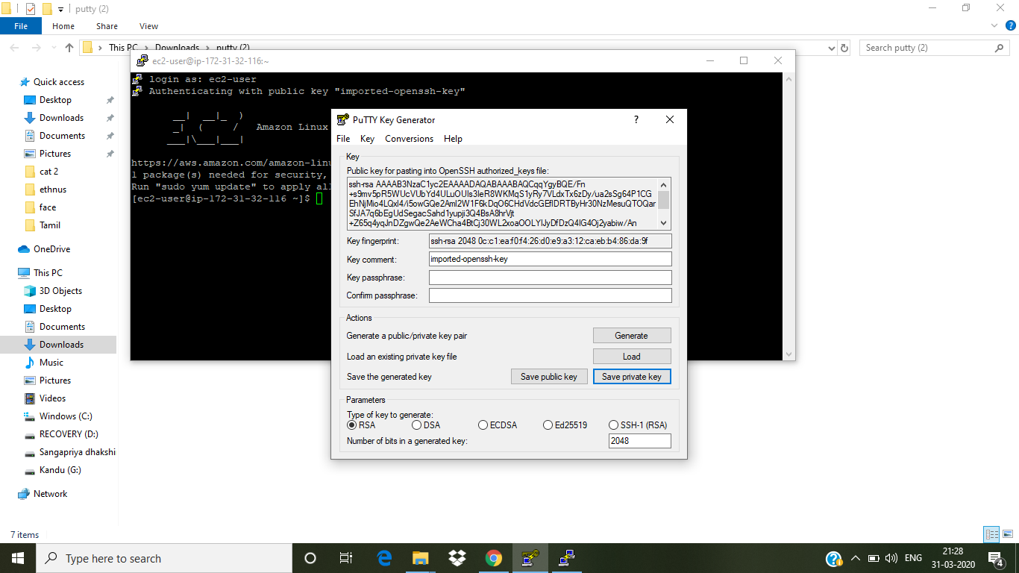

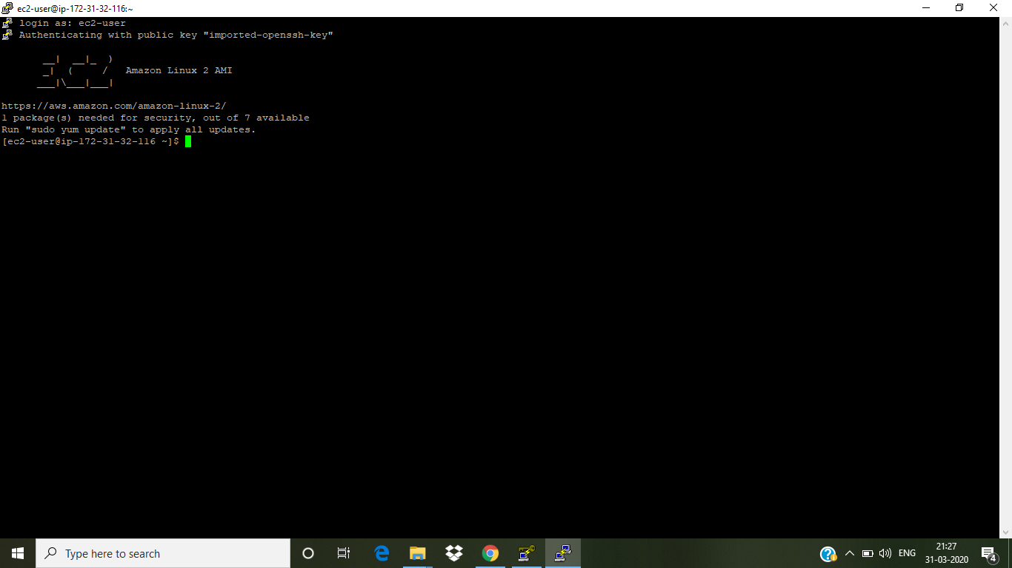

**S3:**



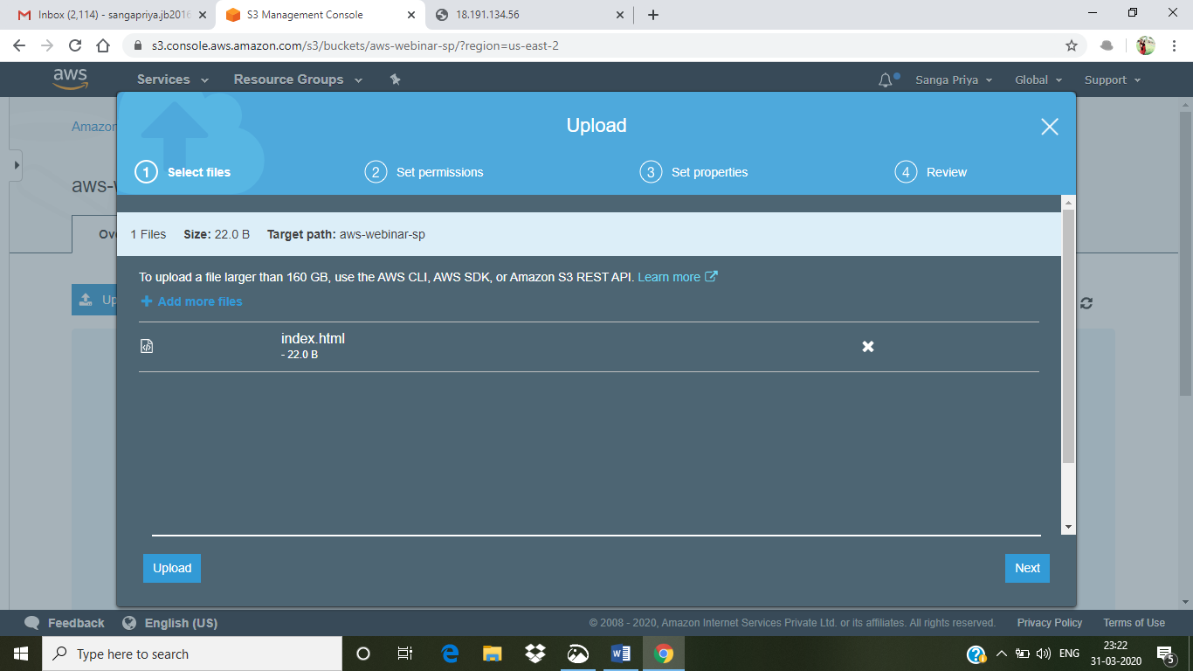

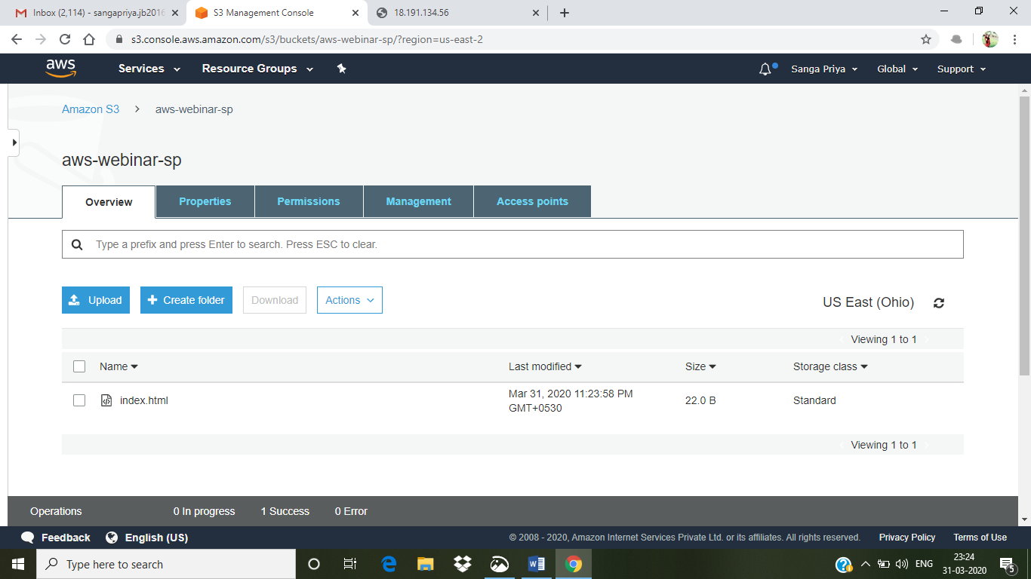

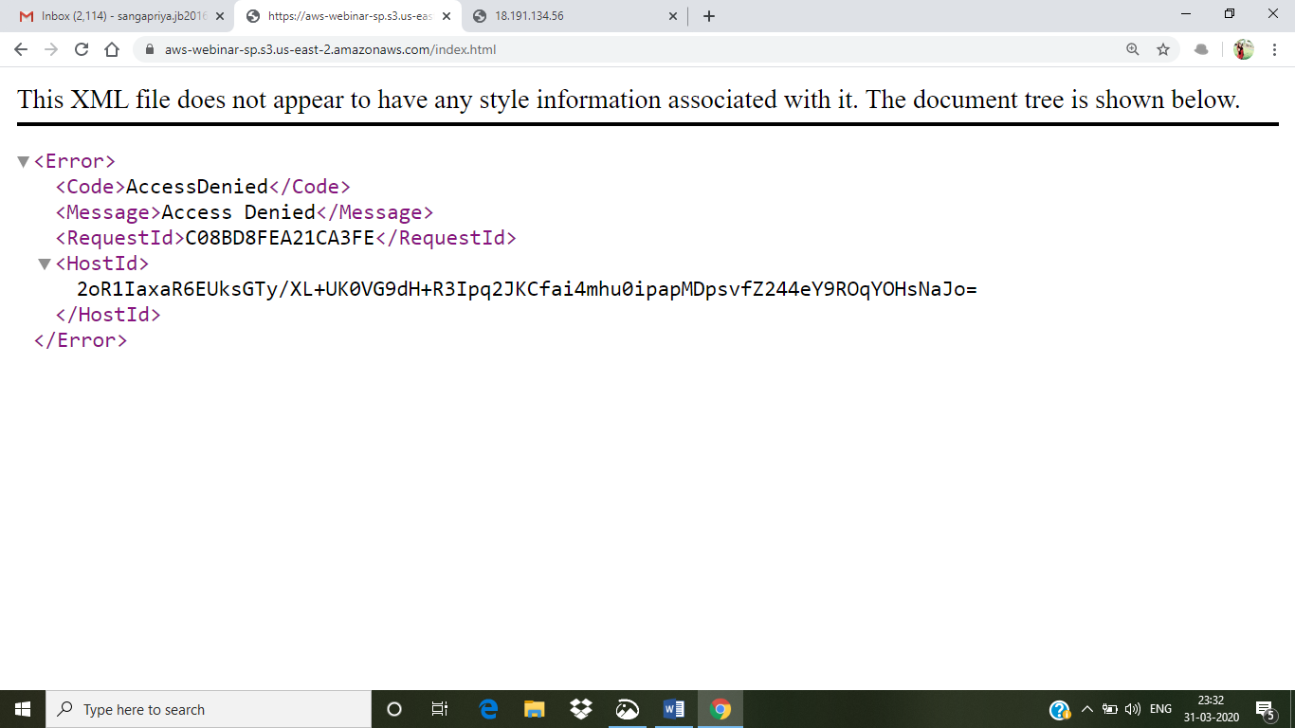

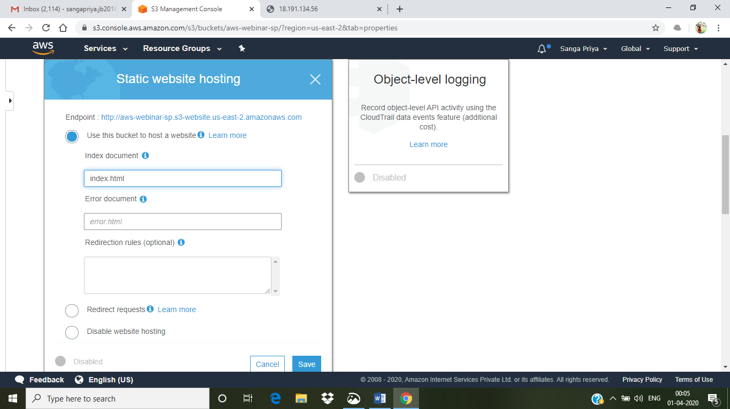

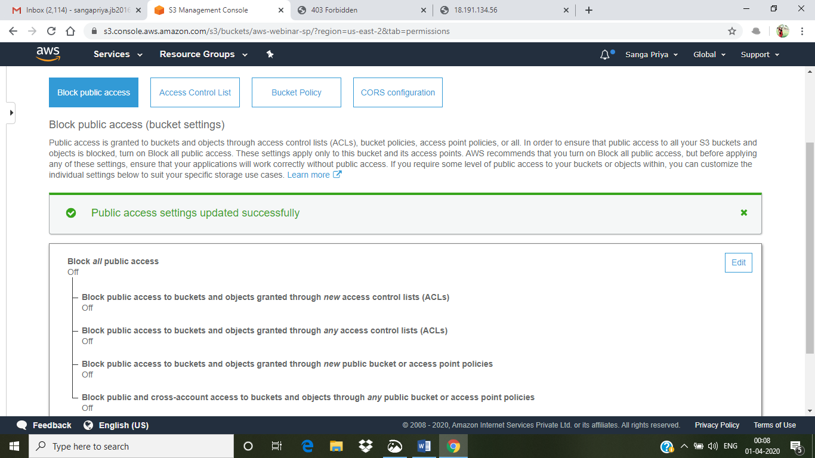

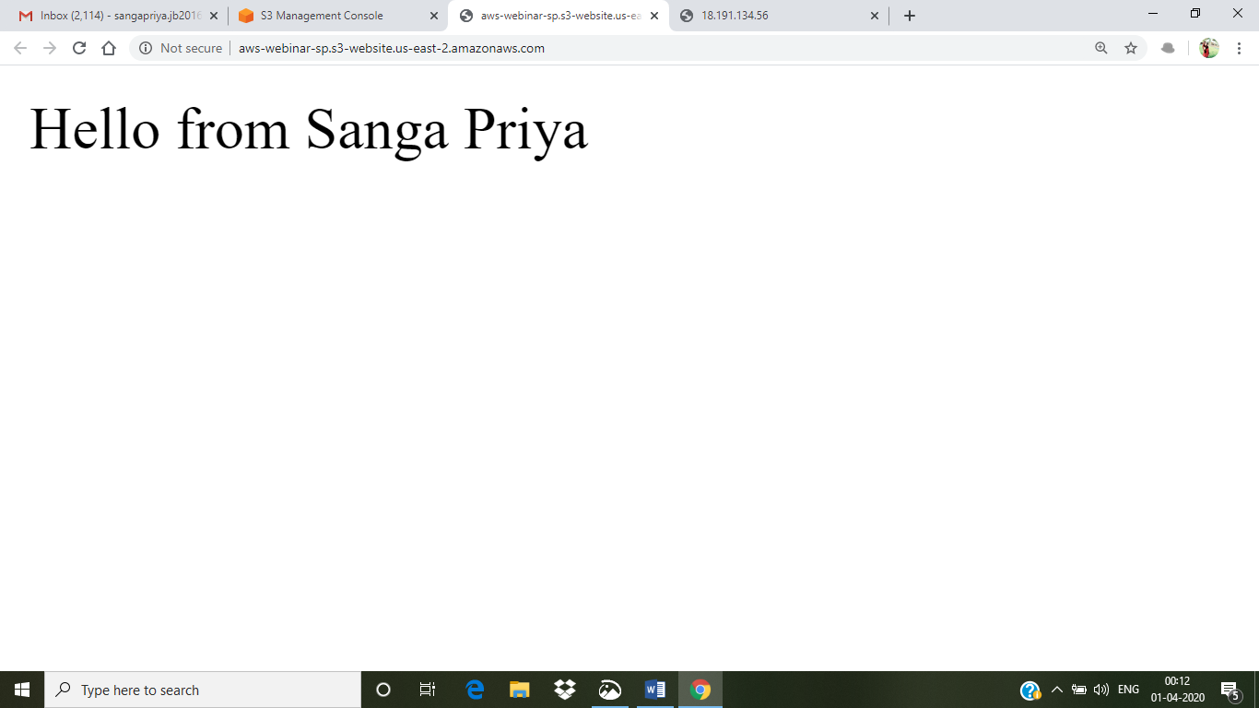

**Rekognition:**



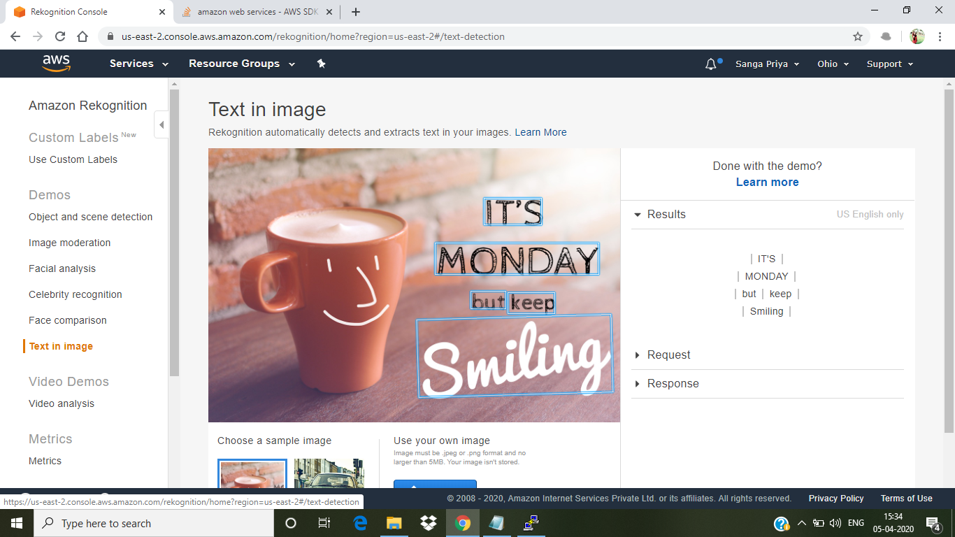

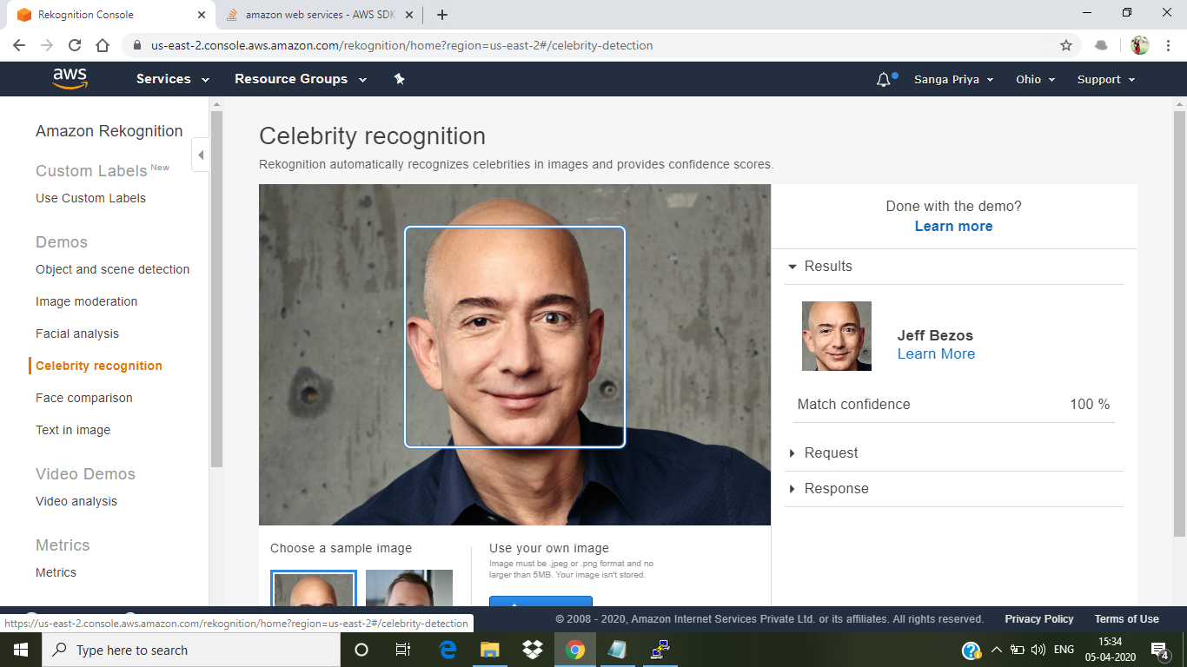

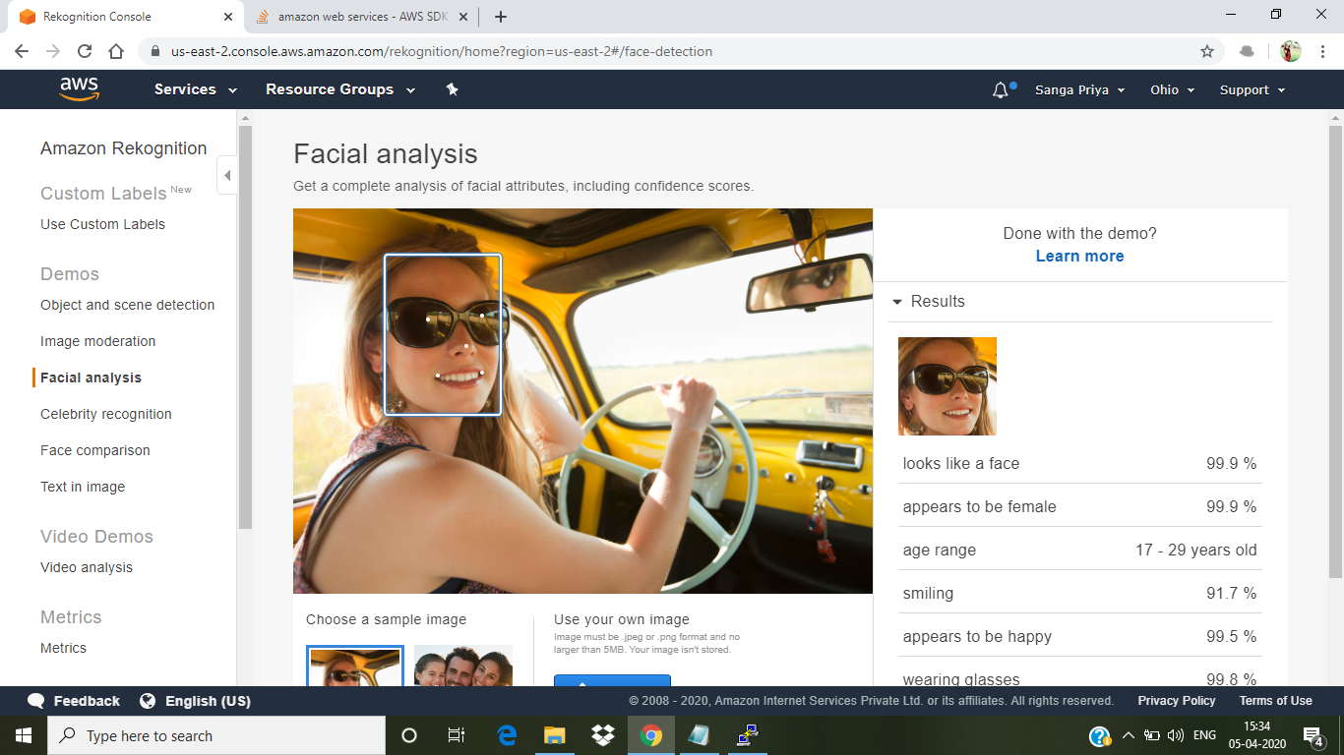

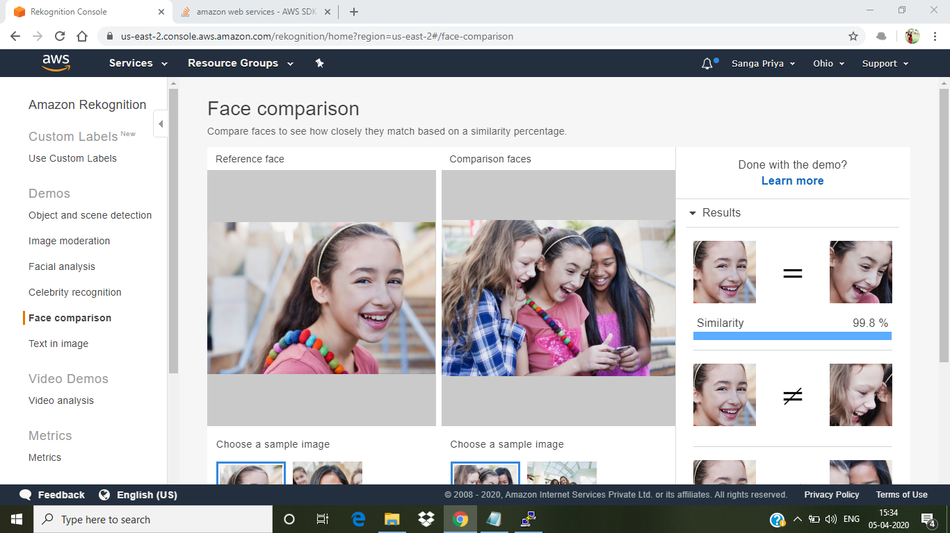

**EC2 AND S3:**

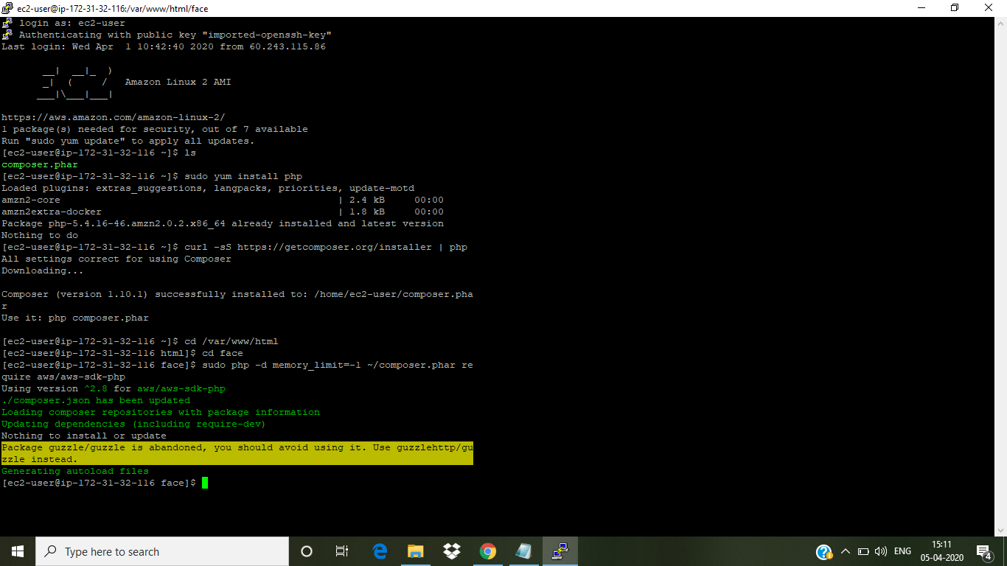

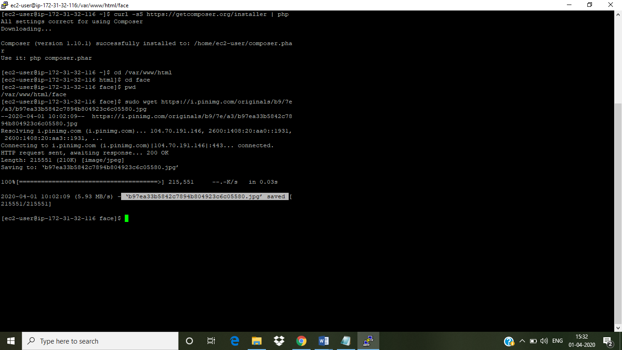

**Index.php file code:**

***<?php***

***/\****

***Install php - sudo yum install php***

***curl -sS https://getcomposer.org/installer | php***

***cd /var/www/html***

***sudo mkdir face***

***cd face***

***sudo php -d memory_limit=-1 ~/composer.phar require aws/aws-sdk-php***

***In case if you get memory error -***

***sudo /bin/dd if=/dev/zero of=/var/swap.1 bs=1M count=1024***

***sudo /sbin/mkswap /var/swap.1***

***sudo /sbin/swapon /var/swap.1***

***sudo wget https://i.pinimg.com/originals/b9/7e/a3/b97ea33b5842c7894b804923c6c05580.jpg***

***sudo mv b97ea33b5842c7894b804923c6c05580.jpg sample.jpg***

***Incase if you are getting any class NOT found error, follow these steps***

***sudo yum remove php\****

***sudo yum remove httpd\****

***sudo yum clean all***

***sudo yum upgrade -y***

***sudo amazon-linux-extras install php7.2***

***sudo yum install php-json php-xml php-cli php-mbstring***

***sudo yum install httpd***

***\*/***

***// error_reporting(0);***

***require_once(__DIR__ . '/vendor/autoload.php');***

***use Aws\S3\S3Client;***

***use Aws\Rekognition\RekognitionClient;***

***$bucket = 'aws-webinar-sp';***

***$keyname = 'sample.jpg';***

***$s3 = new S3Client([***

***'region' => 'us-east-2',***

***'version' => '2006-03-01',***

***'signature' => 'v4'***

***]);***

***try {***

***// Upload data.***

***$result = $s3->putObject([***

***'Bucket' => $bucket,***

***'Key' => $keyname,***

***'SourceFile' => __DIR__. "/$keyname",***

***'ACL' => 'public-read-write'***

***]);***

***// Print the URL to the object.***

***$imageUrl = $result['ObjectURL'];***

***if($imageUrl) {***

***echo "Image upload done... Here is the URL: " . $imageUrl;***

***$rekognition = new RekognitionClient([***

***'region' => 'us-east-2',***

***'version' => 'latest',***

***]);***

***$result = $rekognition->detectFaces([***

***'Attributes' => ['DEFAULT'],***

***'Image' => [***

***'S3Object' => [***

***'Bucket' => $bucket,***

***'Name' => $keyname,***

***'Key' => $keyname,***

***],***

***],***

***]);***

***echo "Totally there are " . count($result["FaceDetails"]) . " faces";***

***}***

***} catch (Exception $e) {***

***echo $e->getMessage() . PHP_EOL;***

***}***

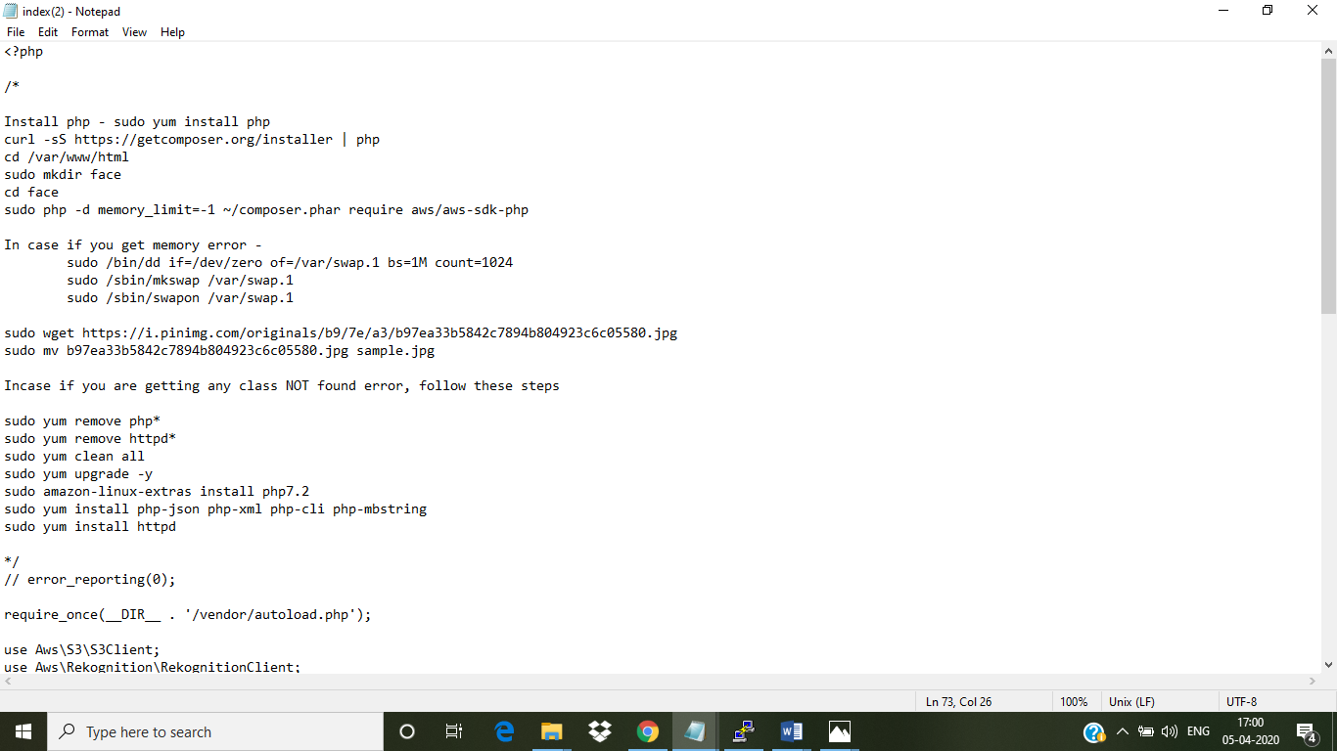

File upload:

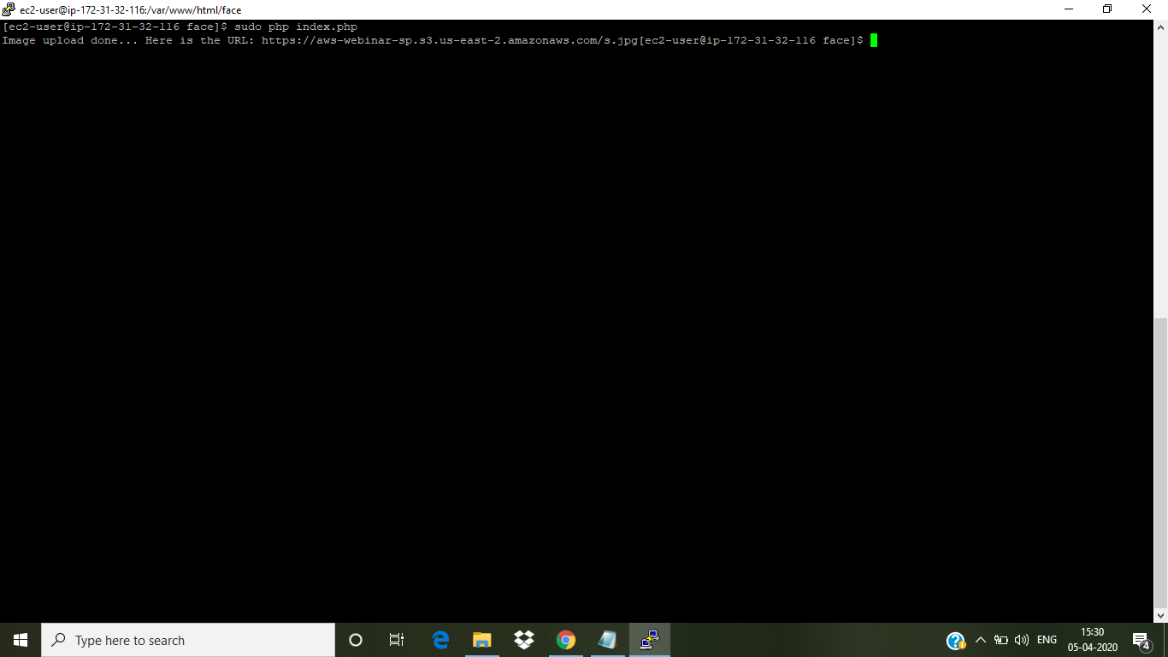

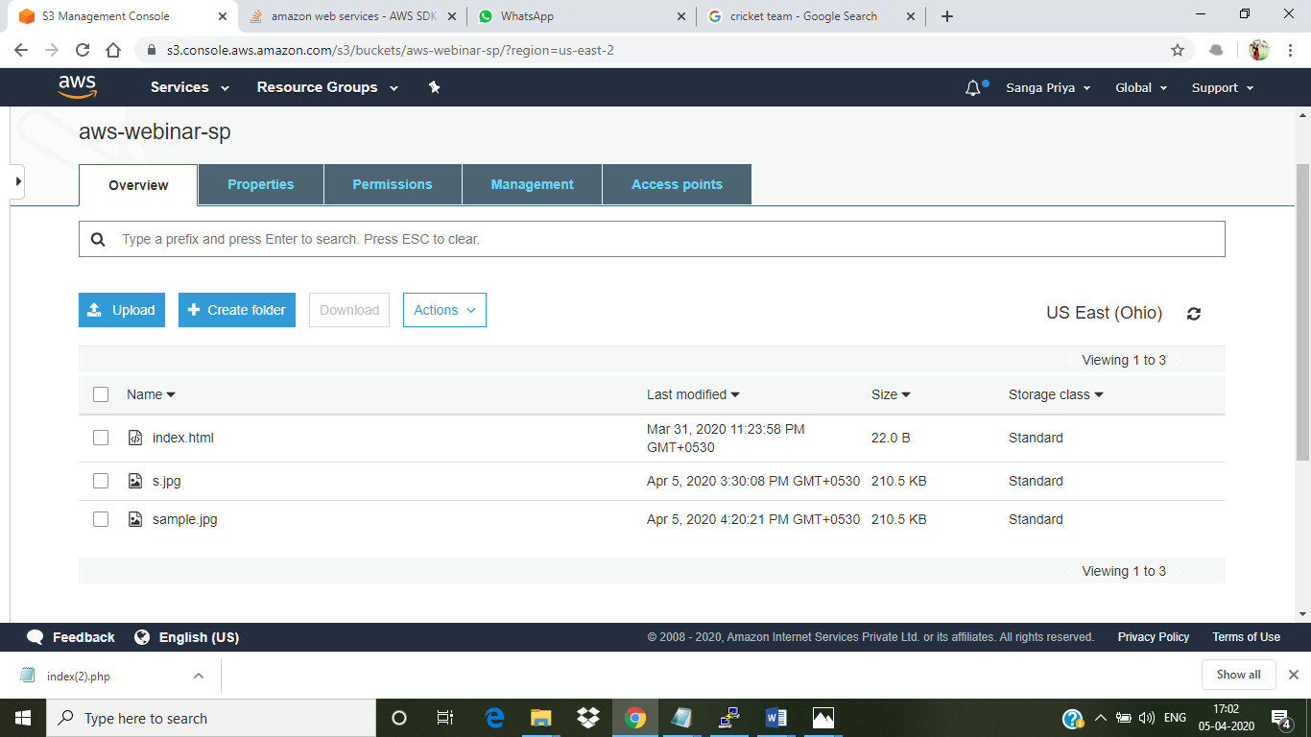

**EC2 AND REKOGNITION:**

